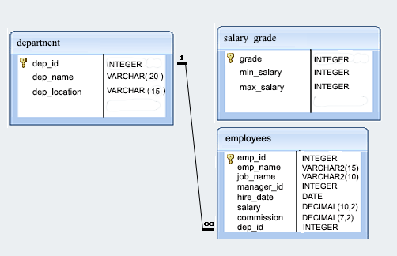

1. From the following table return complete information about the employees.

🡪 SELECT * FROM employees;

1. From the following table, write a SQL query to find the salaries of all employees. Return salary.

🡪 SELECT salary FROM employees;

1. **Add the column to employee table**

**🡪** **ALTER TABLE employee ADD new_column_name datatype;**

1. **Add the column using change clause**

**🡪** **ALTER TABLE employee**

**CHANGE existing_column_name new_column_name datatype;**

1. **Change the datatype of the columne**

**🡪** **ALTER TABLE employee**

**MODIFY column_name new_datatype;**

1. **Add the column constranits using modify clause**

**🡪** **ALTER TABLE employee**

**MODIFY column_name data_type constraint;**

1. **Drop the column**

**🡪** **ALTER TABLE employee**

**DROP COLUMN column_name;**

1. **How to use the ‘after keyword**

**🡪** **ALTER TABLE employee**

**ADD new_column_name datatype AFTER existing_column_name;**